**[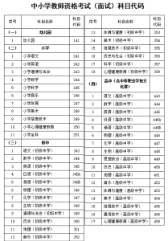](https://oss.yishixue.com/ntce/2022/04/4a47a0db6e60853dedfcfdf08a5ca249-1.png?x-oss-process=image/quality,q_50/resize,m_fill,w_209,h_300)**