附件2

[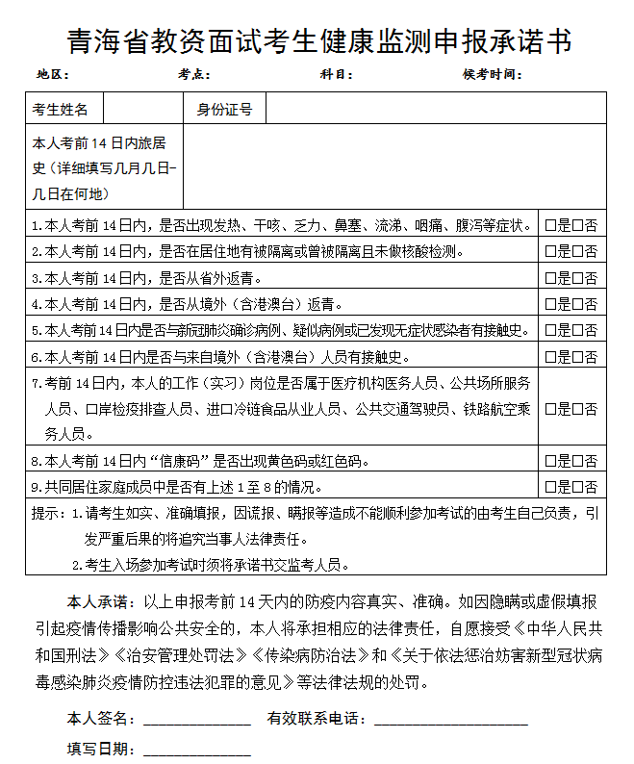](http://www.qhjyks.com/images/content/2022-04/20220428145809193782.PNG)