附件1

[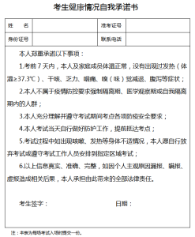](https://oss.yishixue.com/ntce/2022/10/0055d34bd8a63cabe0c4b9332a09a412.png?x-oss-process=image/quality,q_50/resize,m_fill,w_247,h_300)

附件2

[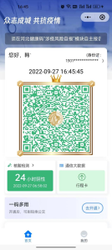](https://oss.yishixue.com/ntce/2022/10/c419d592c55e01a9a28991a774915e99.png?x-oss-process=image/quality,q_50/resize,m_fill,w_134,h_300) [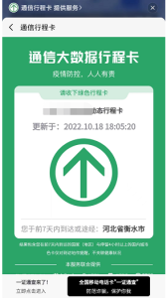](https://oss.yishixue.com/ntce/2022/10/846584e945fd1e9683a7402bb6150e2b.png?x-oss-process=image/quality,q_50/resize,m_fill,w_168,h_300)

注：健康码、行程卡需均为绿码。

附件3

[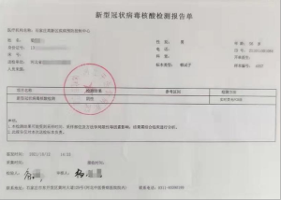](https://oss.yishixue.com/ntce/2022/10/004e53a1882b2e713a3f59f7d407c6b8.png?x-oss-process=image/quality,q_50/resize,m_fill,w_300,h_214)

[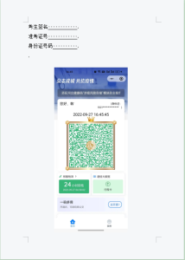](https://oss.yishixue.com/ntce/2022/10/39a0dd0750b1d38dea059ef4043ae89d.png?x-oss-process=image/quality,q_50/resize,m_fill,w_214,h_300)

[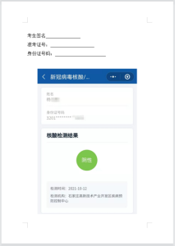](https://oss.yishixue.com/ntce/2022/10/dc386f59da101dafb02df0861a42752f.png?x-oss-process=image/quality,q_50/resize,m_fill,w_213,h_300)