[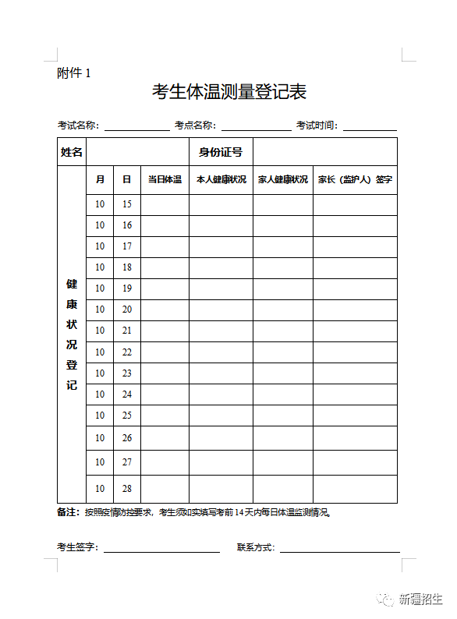](https://oss.yishixue.com/ntce/2022/10/d09638adcad47a85343ea8b54bee2605.png)

[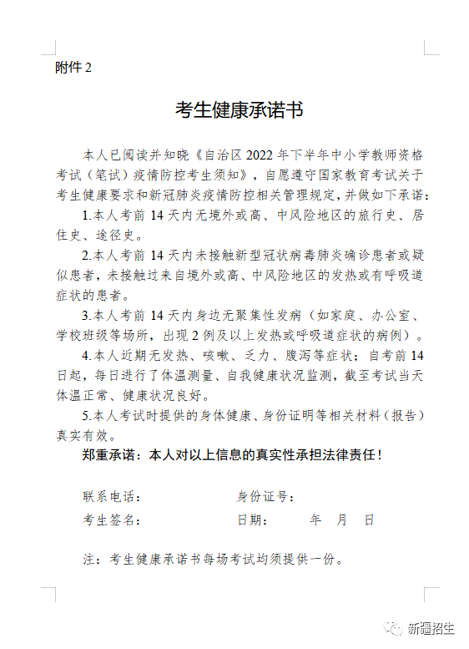](https://oss.yishixue.com/ntce/2022/10/916ba1d780494c121a9287867a9eca76.png)